**9. ReactJS-HOL**

**ListOfPlayers.js**

const players = [

{ name: 'Jack', score: 50 },

{ name: 'Michael', score: 70 },

{ name: 'John', score: 40 },

{ name: 'Ann', score: 61 },

{ name: 'Elisabeth', score: 61 },

{ name: 'Sachin', score: 95 },

{ name: 'Dhoni', score: 100 },

{ name: 'Virat', score: 84 },

{ name: 'Jadeja', score: 64 },

{ name: 'Raina', score: 75 },

{ name: 'Rohit', score: 80 },

];

export default function ListOfPlayers() {

return (

<div>

<h2>List of Players</h2>

<ul>

{players.map((item, index) => (

<li key={index}>Mr. {item.name} {item.score}</li>

))}

</ul>

</div>

);

}

export { players };

**FilteredPlayers.js**

import { players } from './ListOfPlayers';

export default function FilteredPlayers() {

const players70 = [];

players.map((item) => {

if (item.score <= 70) {

players70.push(item);

}

return null;

});

return (

<div>

<h2>List of Players having Scores Less than 70</h2>

<ul>

{players70.map((item, index) => (

<li key={index}>Mr. {item.name} {item.score}</li>

))}

</ul>

</div>

);

}

**OddPlayers.js**

export function OddPlayers({ players }) {

const [first, , third, , fifth] = players;

return (

<div>

<h3>Odd Players</h3>

<ul>

<li>First : {first}</li>

<li>Third : {third}</li>

<li>Fifth : {fifth}</li>

</ul>

</div>

);

}

**EvenPlayers.js**

export function EvenPlayers({ players }) {

const [, second, , fourth, , sixth] = players;

return (

<div>

<h3>Even Players</h3>

<ul>

<li>Second : {second}</li>

<li>Fourth : {fourth}</li>

<li>Sixth : {sixth}</li>

</ul>

</div>

);

}

**IndianPlayers.js**

const T20Players = ['First Player', 'Second Player', 'Third Player'];

const RanjiTrophyPlayers = ['Fourth Player', 'Fifth Player', 'Sixth Player'];

const IndianPlayers = [...T20Players, ...RanjiTrophyPlayers];

export default function IndianPlayersList() {

return (

<div>

<h3>List of Indian Players Merged:</h3>

<ul>

{IndianPlayers.map((player, index) => (

<li key={index}>Mr. {player}</li>

))}

</ul>

</div>

);

}

export { IndianPlayers };

**App.js**

import React from 'react';

import ListOfPlayers from './components/ListOfPlayers';

import FilteredPlayers from './components/FilteredPlayers';

import { OddPlayers } from './components/OddPlayers';

import { EvenPlayers } from './components/EvenPlayers';

import IndianPlayersList from './components/IndianPlayers';

function App() {

const flag = true; // Change to false to see the alternate view

// for Odd and Even Players

const indianTeam = ['Sachin1', 'Dhoni2', 'Virat3', 'Rohit4', 'Yuvraj5', 'Raina6'];

if (flag) {

return (

<div className="App">

<ListOfPlayers />

<FilteredPlayers />

</div>

);

} else {

return (

<div className="App">

<OddPlayers players={indianTeam} />

<EvenPlayers players={indianTeam} />

<IndianPlayersList />

</div>

);

}

}

export default App;

**OUTPUT:**

**When Flag=true**

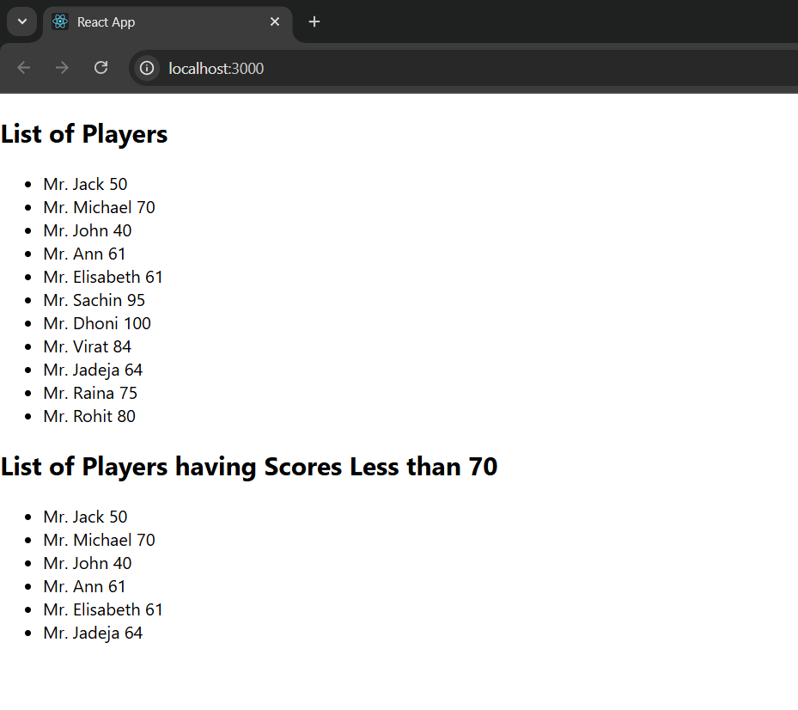

**When Flag=false**

